1. δ=0.1

Because k=2y c=0.8y and y=δk+0.8y

δ=0.1

1. see the roots.m file attached.

[x,val]=fsolve(@roots,[1,1])

Then

x =

3.6739 1.1756

val =

1.0e-06 \*

-0.3440 0.1562

Steady state: k=3.6739, c=1.1756

c) A =

0.0400 -1.0000

-0.0299 0

Then:

[x,lamda]=eig(A)

x =

0.9883 0.9817

-0.1523 0.1905

lamda =

0.1941 0

0 -0.1541

d) tv=linspace(0,50,51)

tv=tv’

choose lamda=-0.1541

associated eigen vector is (0.9817 0.1905)’

k-ks=0.9817exp(-0.1541\*t)\*R

c-cs=0.1905exp(-0.1541\*t)\*R

notice R is a constant.

For initial value k0=0.10ks, we have R= -3.3681.

Then

C(t)=cs-3.3681\*0.1905exp(-0.1541\*t)= 1.1756-3.3681\*0.1905exp(-0.1541\*t)

K(t)=ks-3.3681\*0.9817exp(-0.1541\*t)= 3.6739-3.3681\*0.9817exp(-0.1541\*t)

In matlab:

cv=1.1756-3.3681\*0.1905\*exp(-0.1541\*tv);

kv=3.6739-3.3681\*0.9817\*exp(-0.1541\*tv);

are the vectors that we want.

For initial value k0=1.50ks, we have R=1.8712

cv=1.1756+1.8712\*0.1905\*exp(-0.1541\*tv);

kv=3.6739+1.8712\*0.9817\*exp(-0.1541\*tv);

are the vectors that we want.

e) plot the first one, k0=0.1ks

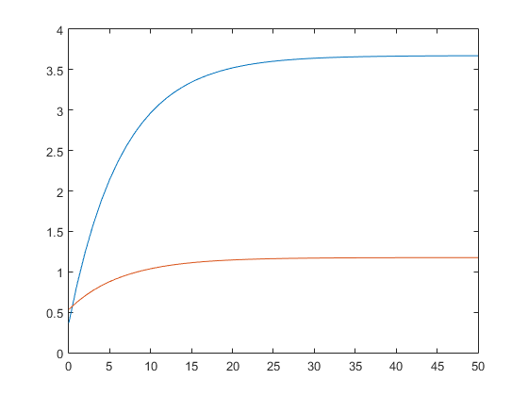

Plot the second case, which is k0=1.5ks

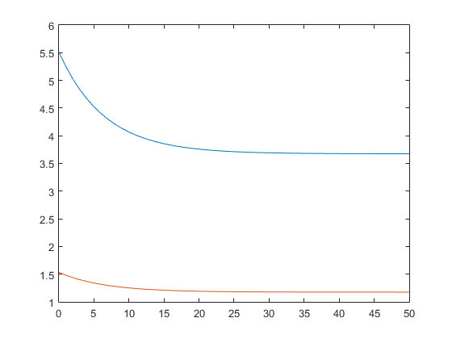

f)

kx=linspace(0.36739,1.5\*3.6739,100);

below is the locus for k’=0, namely, cx=kx^(1/3)-0.1\*kx

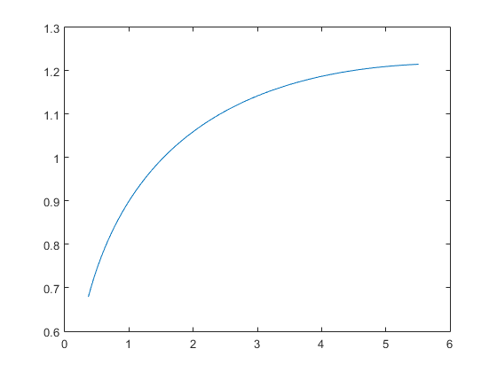

Equilibrium path:

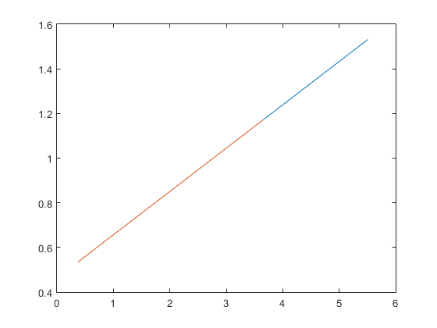

g) for rho=2,

A =

0.040000000000000 -1.000000000000000

-0.014950000000000 0

>> [x,lam]=eig(A)

x =

0.994646205984209 0.989805146755738

-0.103338883878329 0.142428127333934

lam =

0.143895116933639 0

0 -0.103895116933639

Lamda=-0.104>-0.15

So the rate of convergence is slower compared to rho=1.

The steady state does not change as rho does not enter the two equations for k’=0 and c’=0.